What is Artificial Neural Network?

The term “[**Artificial Neural Network**](https://www.analyticsvidhya.com/blog/2021/12/artificial-neural-network-impementations/)” is derived from biological neural networks, which define the structure of the human brain. Artificial neural networks, like the human brain, have neurons in multiple layers that are connected to one another. These neurons are referred to as nodes.

In ANN, dendrites from biological neural networks represent inputs, cell nuclei represent nodes, synapses represent weights, and axons represent the output.

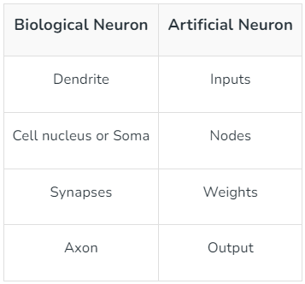

ANNs are nonlinear statistical models that demonstrate a complex relationship between inputs and outputs in order to uncover a new pattern. Artificial neural networks are used for a range of applications, including image recognition, speech recognition, machine translation, and medical diagnosis.

The fact that ANN learns from sample data sets is a significant advantage. The most typical application of ANN is for random function approximation. With these types of technologies, one can arrive at solutions that specify the distribution in a cost-effective manner. ANN can also offer an output result based on a sample of data rather than the complete dataset. ANNs can be used to improve existing data analysis methods due to their high prediction capabilities.

Artificial Neural Networks Architecture

A node layer contains an input layer, one or more hidden layers, and an output layer in ANNs. Each node, or artificial neuron, has its own weight and threshold and is connected to the others. When a node’s output hits a certain threshold, it is activated, and data is sent to the next tier of the network. No data is sent to the next tier of the network if this is not the case.

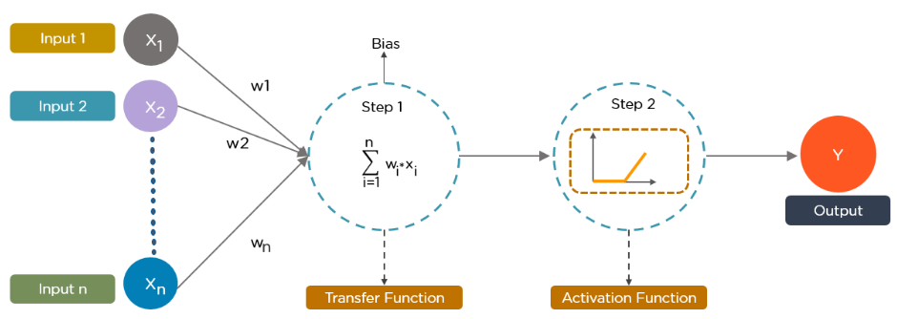**Source**: Bosem.com

The cost function can be minimized using one of two methods:

1. **Back Propagation:**Backpropagation is at the heart of neural network training. It is the most important way for neural networks to learn. The data enters the input layer and travels across the network to the output layer. The cost function will then equate the output with the intended output. If the cost function’s value is high, the information is returned, and the neural network learns to reduce the cost function’s value by modifying the weights. The error rate is reduced and the model becomes definite when the weights are properly adjusted.
2. **Forward Propagation:** The data enters the input layer and travels across the network to the output value. The value is compared to the expected results by the user. Calculating mistakes and transmitting information backwards is the next stage. The user can now train the neural network and update the weights. The user can alter weights simultaneously thanks to the structured algorithm. It will assist the user in dete

Artificial Neural Network Applications

Following are some important ANN Applications –

1. **Speech Recognition:**Speech recognition relies heavily on artificial neural networks (ANNs). Earlier speech recognition models used statistical models such as Hidden Markov Models. With the introduction of deep learning, several forms of neural networks have become the only way to acquire a precise classification.
2. **Handwritten Character Recognition:**ANNs are used to recognize handwritten characters. Handwritten characters can be in the form of letters or digits, and neural networks have been trained to recognize them.
3. **Signature Classification:**We employ artificial neural networks to recognize signatures and categorize them according to the person’s class when developing these authentication systems. Furthermore, neural networks can determine whether or not a signature is genuine.
4. **Medical:**It can be used to detect cancer cells and analyze MRI pictures in order to provide detailed results.